There is a long and thin painting that can be represented by a number line. The painting was painted with multiple overlapping segments where each segment was painted with a **unique** color. You are given a 2D integer array segments, where segments[i] = [starti, endi, colori] represents the **half-closed segment** [starti, endi) with colori as the color.

The colors in the overlapping segments of the painting were **mixed** when it was painted. When two or more colors mix, they form a new color that can be represented as a **set** of mixed colors.

* For example, if colors 2, 4, and 6 are mixed, then the resulting mixed color is {2,4,6}.

For the sake of simplicity, you should only output the **sum** of the elements in the set rather than the full set.

You want to **describe** the painting with the **minimum** number of non-overlapping **half-closed segments** of these mixed colors. These segments can be represented by the 2D array painting where painting[j] = [leftj, rightj, mixj] describes a **half-closed segment** [leftj, rightj) with the mixed color **sum** of mixj.

* For example, the painting created with segments = [[1,4,5],[1,7,7]] can be described by painting = [[1,4,12],[4,7,7]] because:
  + [1,4) is colored {5,7} (with a sum of 12) from both the first and second segments.
  + [4,7) is colored {7} from only the second segment.

Return *the 2D array*painting*describing the finished painting (excluding any parts that are****not****painted). You may return the segments in****any order***.

A **half-closed segment** [a, b) is the section of the number line between points a and b **including** point a and **not including** point b.

**Example 1:**

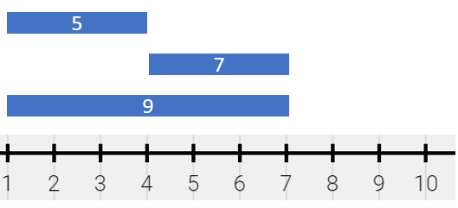

**Input:** segments = [[1,4,5],[4,7,7],[1,7,9]]

**Output:** [[1,4,14],[4,7,16]]

**Explanation:** The painting can be described as follows:

- [1,4) is colored {5,9} (with a sum of 14) from the first and third segments.

- [4,7) is colored {7,9} (with a sum of 16) from the second and third segments.

**Example 2:**

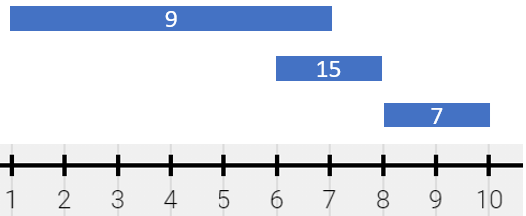

**Input:** segments = [[1,7,9],[6,8,15],[8,10,7]]

**Output:** [[1,6,9],[6,7,24],[7,8,15],[8,10,7]]

**Explanation:** The painting can be described as follows:

- [1,6) is colored 9 from the first segment.

- [6,7) is colored {9,15} (with a sum of 24) from the first and second segments.

- [7,8) is colored 15 from the second segment.

- [8,10) is colored 7 from the third segment.

**Example 3:**

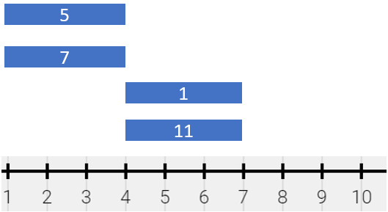

**Input:** segments = [[1,4,5],[1,4,7],[4,7,1],[4,7,11]]

**Output:** [[1,4,12],[4,7,12]]

**Explanation:** The painting can be described as follows:

- [1,4) is colored {5,7} (with a sum of 12) from the first and second segments.

- [4,7) is colored {1,11} (with a sum of 12) from the third and fourth segments.

Note that returning a single segment [1,7) is incorrect because the mixed color sets are different.

**Constraints:**

* 1 <= segments.length <= 2 * 104
* segments[i].length == 3
* 1 <= starti < endi <= 105
* 1 <= colori <= 109
* Each colori is distinct.